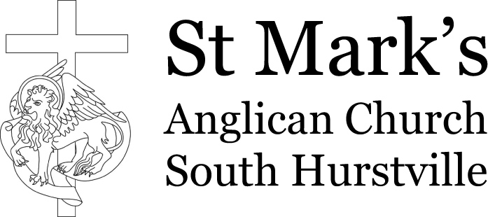 | Weekly offerings

Week ending Sunday: | _____/_____/ 20____ |  | Service Totals
Sunday 8am Eucharist | Date:
 | General offerings | $
Unspecified donations / Special objects |  | $
 |  | $
 |  | $
 |  | $
 |  | $ | $
Two signatures | 1. 2.
Other services (specify title) | Date:
 | General offerings | $
 |  | $
Unspecified donations / Special objects |  | $
 |  | $ | $
Two signatures | 1. 2.
Miscellaneous income | Flowers | $
 | Home Communion | $
 | ABM | $
 | Christmas Bowl | $
 | Bible Reading Fellowship | $
 |  | $ | $
Signature
WEEKLY TOTAL | General Offerings | $
 | Donations/Special objects | $
 |  | Total Banked | $
Signature

Definitions

General offerings – the normal plate offerings (cash and envelopes) of worshippers.

Unspecified donations – ad-hoc donations for which the purpose is unspecified (eg funeral donation).

Special objects – ad-hoc gifts or event proceeds that are specified for a particular purpose (eg Flowers).

Service Total – the total normal income for that service/event.

Counting

Two unrelated St Mark's members should count and record the offerings.

